Megakaryocytes Might Facilitate Adult Stem Cell Regeneration

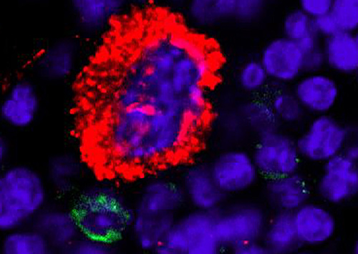

A hematopoietic stem cell (green) attaches to a megakaryocyte (red) in bone marrow. [Meng Zhao, Ph.D., Linheng Li Lab, Stowers Institute for Medical Research]

- Scientists from the Stowers Institute for Medical Research have discovered that megakaryocytes, best known for producing platelets that heal wounds, also play a critical role in regulating stem cells. In fact, hematopoietic stem cells differentiate to generate megakaryocytes in bone marrow. The Stowers research reportedly is the first to show that hematopoietic stem cells (the parent cells) can be directly controlled by their own progeny (megakaryocytes).
The study ("Megakaryocytes maintain homeostatic quiescence and promote post-injury regeneration of hematopoietic stem cells"), published in Nature Medicine, could cause researchers to rethink what they know about the workings of megakaryocytes and potentially lead to new treatments for patients recovering from chemotherapy or organ transplantation.
"Our results suggest that megakaryocytes might be used clinically to facilitate adult stem cell regeneration and to expand cultured cells for adult stem cell transplants," says Meng Zhao, Ph.D., a postdoctoral fellow at Stowers and lead author on the study.
Stowers researchers discovered that megakaryocytes directly regulate the function of murine hematopoietic stem cells. These cells can also develop into all types of blood cells, including white blood cells, red blood cells, and platelets.
Because of their ability to renew themselves and differentiate into other cells, hematopoietic stem cells are the focus of intense research and have been used to treat many diseases and conditions. The transplantation of isolated human hematopoietic stem cells is used in the treatment of anemia, immune deficiencies, and other diseases including cancer.
Basic research has centered on identifying and characterizing hematopoietic stem cells. However, it is still not clear how hematopoietic stem cells actually work, and how they are regulated because of the complexity of the bone marrow microenvironment. Dr. Zhao and his colleagues discovered that as a terminally differentiated progeny, megakaryocytes regulate hematopoietic stem cells by performing two previously unknown functions.
"Megakaryocytes can directly regulate the amount of hematopoietic stem cells by telling the cells when they need to keep in the quiescent stage, and when they need to start proliferating to meet increased demand," Maintaining that delicate balance is important, he adds. "You don't want to have too many or too few hematopoietic stem cells."
Employing the technology of the Institute's cytometry, imaging, and histology centers, the researchers examined the relationship between megakaryocytes and hematopoietic stem cells in mouse bone marrow. In the course of their research, they found that the protein transforming growth factor B1 (TGF-B1), contained in megakaryocytes, signaled quiescence of hematopoietic stem cells. They also found that when under stress from chemotherapy, megakaryocytes signaled fibroblast growth factor 1 (FGF1), to stimulate the proliferation of hematopoietic stem cells.
"[Our] data demonstrate that TGF-β1 is a dominant signal emanating from MKs [megakaryocytes] that maintains HSC quiescence. However, under conditions of chemotherapeutic challenge, MK ablation resulted in a severe defect in HSC [hematopoietic stem cell expansion]," wrote the investigators. "In response to stress, fibroblast growth factor 1 (FGF1) signaling from MKs transiently dominates over TGF-β inhibitory signaling to stimulate HSC expansion. Overall, these observations demonstrate that MKs serve as HSC-derived niche cells to dynamically regulate HSC function."
"Our findings suggest that megakaryocytes are required for the recovery of hematopoietic stem cells post chemotherapy," explains lab Stowers investigator Linheng Li, Ph.D.
The discovery could provide insight for using megakaryocyte-derived factors, such as TGF-B1 and FGF1, clinically to facilitate regeneration of hematopoietic stem cells, he adds.

